**CSE211 Web Programming, Fall Semester 24/25**

**Assignment 1: Websites Conceptual Design and Mock-up**

**Seif-eldeen Mohamed Mostafa,222200039,CE**



Web 2.0 as a web of people connections, Web 3.0 as a web of knowledge connections and web4.0 as a web

Intelligence connections are described as four generations of the web.

. (International Journal for Science and Advance Research in Technology)



Rich user experience, user participation, dynamic content, metadata, Web standards, and scalability.(Wikipedia)



The notable features of web 3.0 would include the semantic web, decentralization, artificial intelligence, connectivity and ubiquity and spatial computing. (101 Blockchains)



Web 4.0 focuses on delivering highly personalized and context-aware experiences to users. By harnessing data from various sources, including social media, browsing behavior, and location, its applications can adapt to individual preferences, anticipate user needs, and deliver tailored content.(LCX Exchange)



Collective intelligence has been proposed, a shared agreement suggests that Collective Intelligence is a group or shared intelligence that emerges from the collaboration and or competition of many entities, either human or digital .(Science Direct)

The importance of Social networking If you have a good dentist and your friend needs a dentist you will recommend your dentist. If your friend likes the dentist and their friend has a tooth issue they will also recommend your dentist. Slowly people will network and pass along valuable dental information. At the end of the day the dentist increases in popularity and business, without even advertising. This harnesses the importance of social networking sites for the web. The importance of social networking relates to increasing traffic to your site and increasing awareness for your site. This means that more people will become exposed to your business, which means more users to convert to sales.(OPTIMUS)

Social bookmarking is an effective way to promote content and increase traffic to a website. It helps create a community of users who share relevant links and content, which can help increase a website’s visibility and search engine rankings. It can also help build relationships between users and brands, and provide an easy way to share content and stay up to date on the latest trends.(ResearchGate)



By using social media, many companies try to exploit new forms of interaction, collaboration, and knowledge sharing through leveraging the social, collaborative dimension of social software. The traditional collective knowledge management model based on a top-down approach is now opening up new avenues for a bottom-up approach incorporating a more personal knowledge management dimension, which could be synergized into collective knowledge using the social-collaborative dimension of social media.(ResearchGate)



You can use collective intelligence to join or contribute to platforms like ISACs (Information Sharing and Analysis Centers) to detect and mitigate cyber threats faster.(ResearchGate)

You can use social networks toTrack public data on social networks to identify potential security risks, such as phishing attempts, data leaks, or threat actor activities.(ResearchGate)

You can use Social media to Create engaging social media campaigns for public education on topics like phishing, password hygiene, or safe browsing habits.(ResearchGate)

References:

1.<https://www.researchgate.net/publication/324537592_Web_Technologies_From_Web_20_To_Web_40>

2.<https://en.wikipedia.org/wiki/Web_2.0>

3.<https://101blockchains.com/top-web3-features/>

4.<https://www.lcx.com/introduction-to-web-4-0/>

5.<https://www.researchgate.net/publication/262949343_Social_Media_in_Organizations_Leveraging_Personal_and_Collective_Knowledge_Processes>

**Seif-eldeen Mohamed Mostafa,222200039,CE**

**Website planning**

It is a local brand for Classic and Casual Clothes.****

I want to develop my local brand,make it easier to make orders on my site and contact customers.

Women,Men and Kids who are interested in fashion and trendy.

Opportunities: Client Can Customize any design he or she loves on my website and The website could help the brand reach a wider audience beyond its local area, especially through online shopping and social media integration.

Problems:Limited Physical Store Access The website can provide a convenient online shopping option for customers who cannot easily visit physical stores.

Issues:Trust and Security Concerns The website can build trust by displaying customer reviews, certifications, and Influencers make reviews about my website.

Bags designs,trendy socks and sleeve bags.



We’ve designed our website to make it easy for clients to find the products they love. With a simple and beautiful interface, you can effortlessly browse our collection and place orders. Our dedicated support team is always ready to assist you with any questions or concerns, ensuring a seamless shopping experience.



Clients can go to Categories to select Men, Women, or Kids, then go to Products to select a product and add it to their cart to checkout. The order will then be delivered.



Use a clear and concise menu structure that is easy to understand and navigate and Use high-quality images and videos to showcase My products and attract user attention.



The results will show up right on the page, either where clients searched or in a new section below



Clients can use feedback to improve products and make it best.



The results will be shared with the public through Whatsapp Group,Instagram and Facebook.



We should follow up surveys and feedback from clients to help them and make the website better than first.



American Eagle, SHEIN, and Bershka. These sites are professionally designed, with beautiful and simple color schemes. They make it easy to find products and place orders.

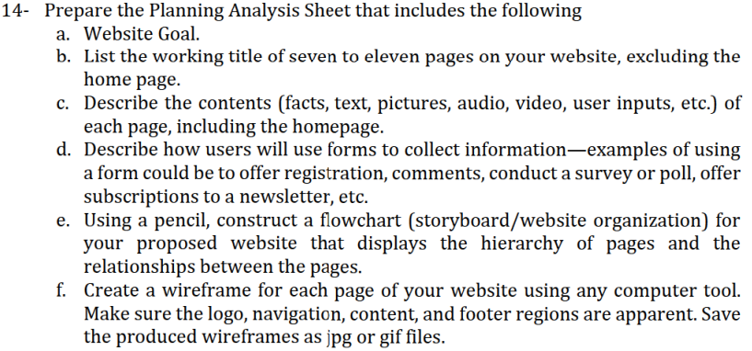

1. Local Clothing Brand to Classic and Casual type
2. Categories,Products,Design,Customize,Login,Cart,Contact-us
3. Home page: brand name , logo , photo from my Products , footer  
   Categories:brand name , logo, man or kids or women and photos for us from my products , footer  
   Products:brand name , logo, shirts or hoodie or jackets and photos from my products,footer  
   design:brand name , logo, classic or casual and photos from my products,footer  
   customize:brand name , logo,customization option and photos from my products,footer  
   Login:brand name , logo, mail and password to login,footer  
   contact -us:brand name , logo,name,phone number,mail,subject and description to feedback or problem,footer  
   about -us:brand name , logo,brief for my brand ,footer
4. From the contact us option client can put name and mail and phone number and problem or feedback to contact.
5. 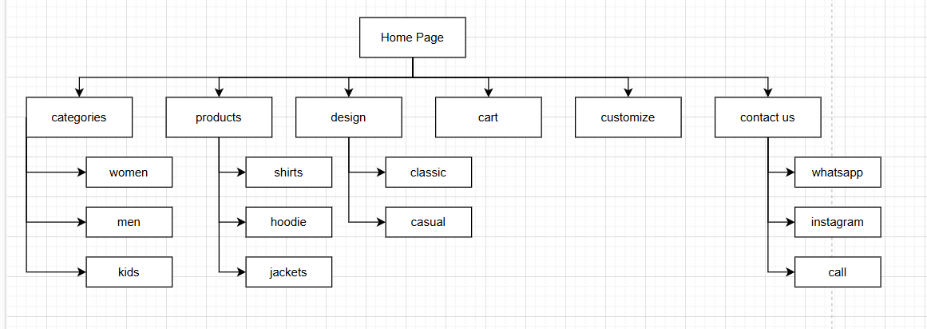

**Seif-eldeen Mohamed Mostafa,222200039,CE**

**Website design**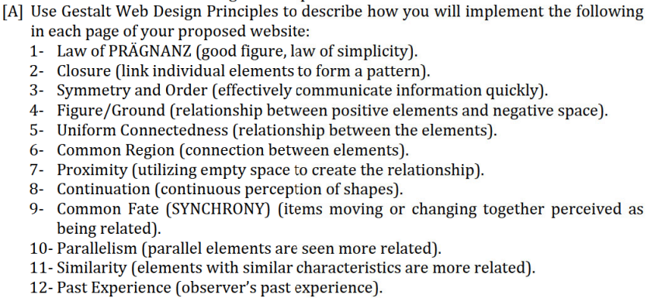

Proximity: Related elements such as “categories”, “products”, “design”, “customize” and “contact” have been placed adjacent to one another.

Similarity: A common typeface and color have been applied for the navigation bar creating a sense of cohesiveness.

Closure: The arrangement is straightforward, and there are clear divisions that allow the interface users to get the general picture easily.

Visual Hierarchy:

Figure-Ground: The area that is supposed to capture the most attention from a user, for instance, the products or the designs area is advanced out of most other areas.

Emphasis: Important ideas have been emphasized by the use of headlines that are larger and in bold typefaces than the other text on the page.

User Experience:

Common Fate: There is a possibility that some animations or transitions may serve to grab the user's attention or show their areas of interaction.

Past Experience: Judging by the navigation structure and the layout, one can assume that this website adheres to the conventional norms of web design thus it is intuitive.

Additional Considerations:

Simplicity: Based on the fact that the image does not show the complete scenario of the situation, it appears that the plan is making use of a minimalistic style which abides by the Law of Prägnanz.

Consistency: Uniform visual elements should be consistently used throughout the page in order to present a professional appearance.

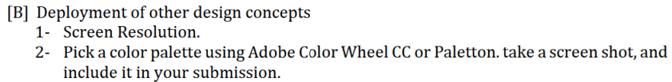

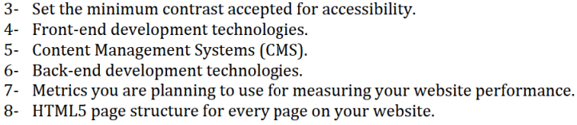

Home page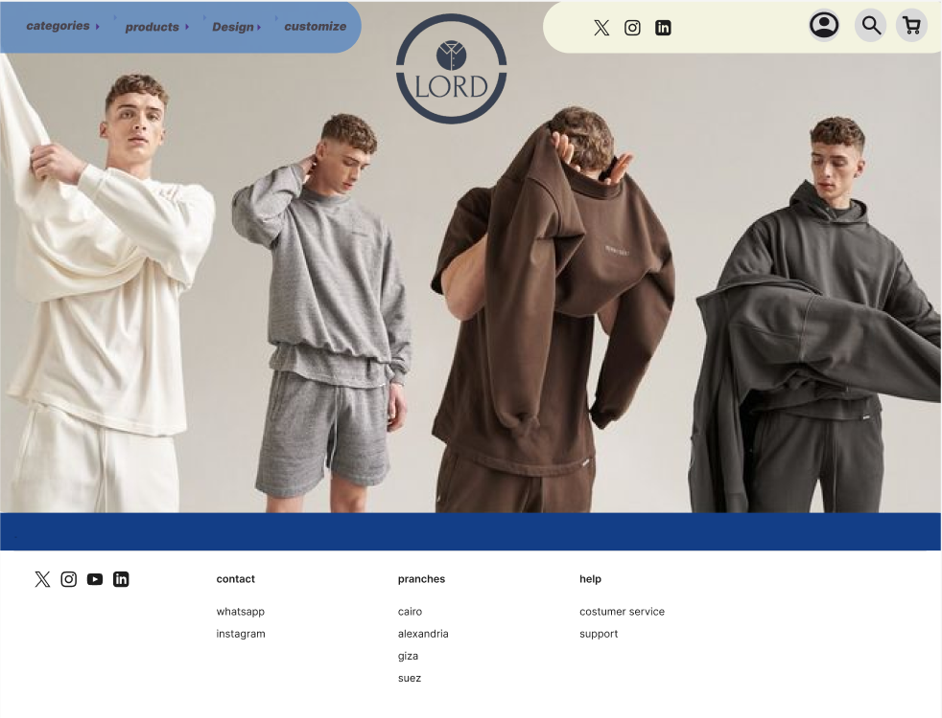

Categories page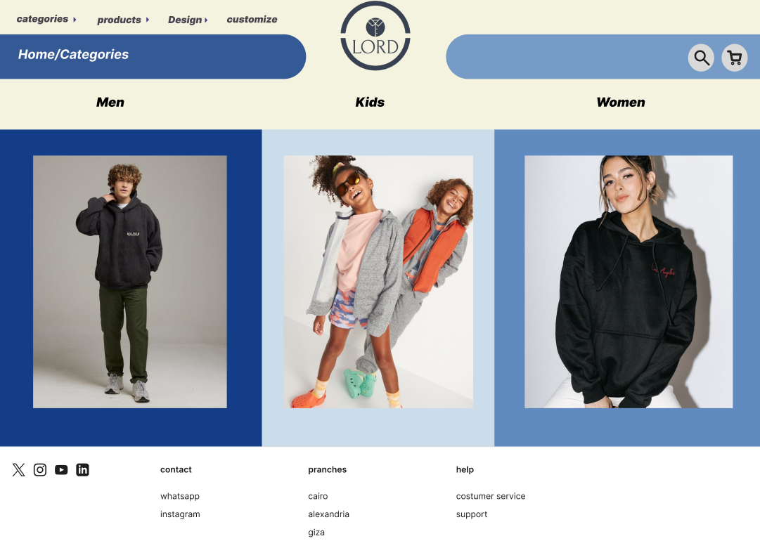

Products page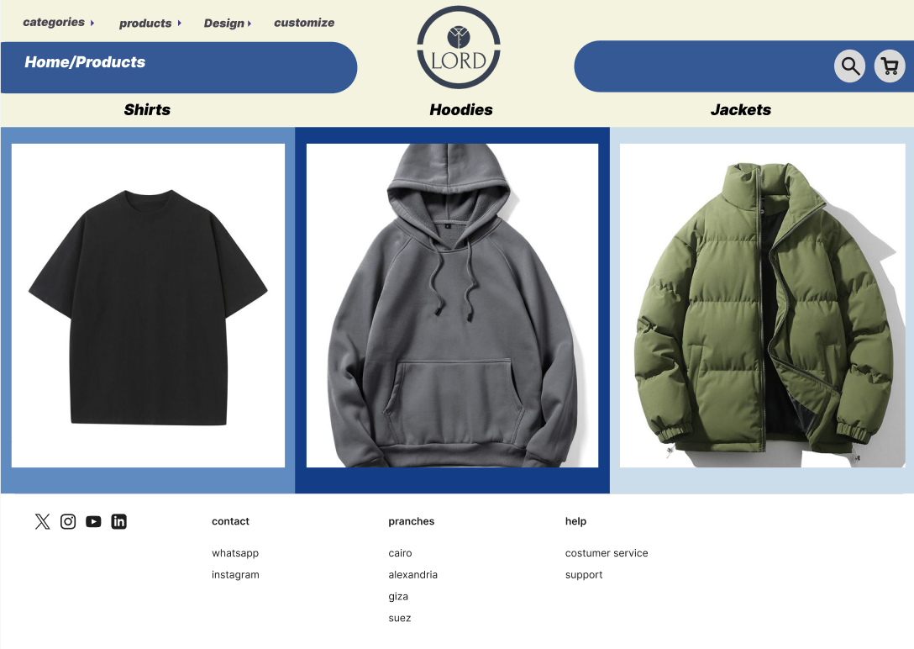

Design page

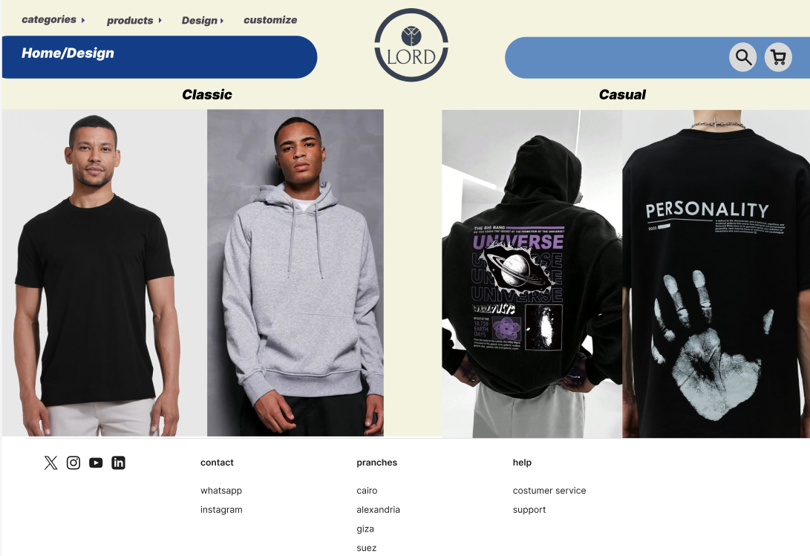

Contact us page

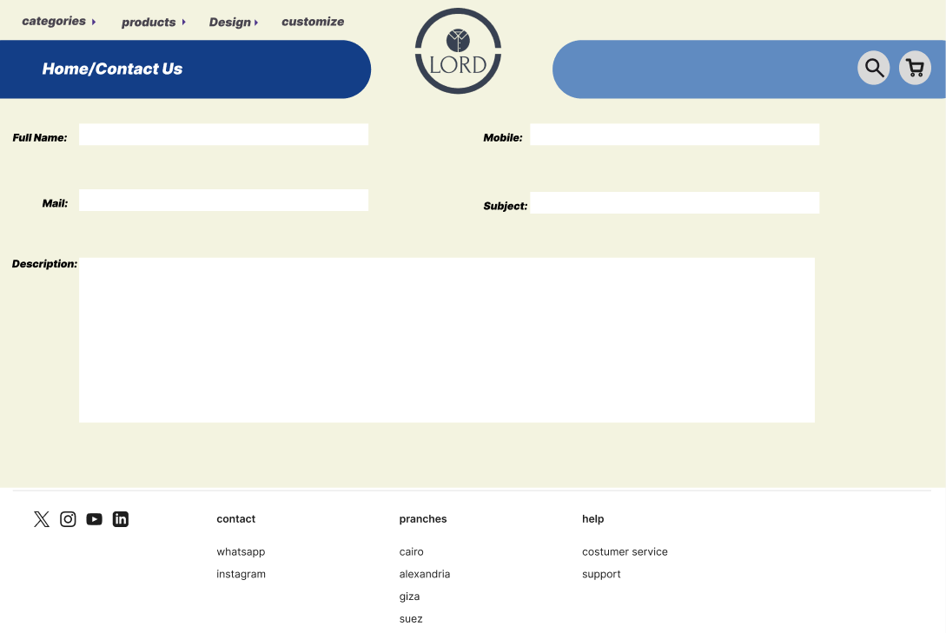

About us page

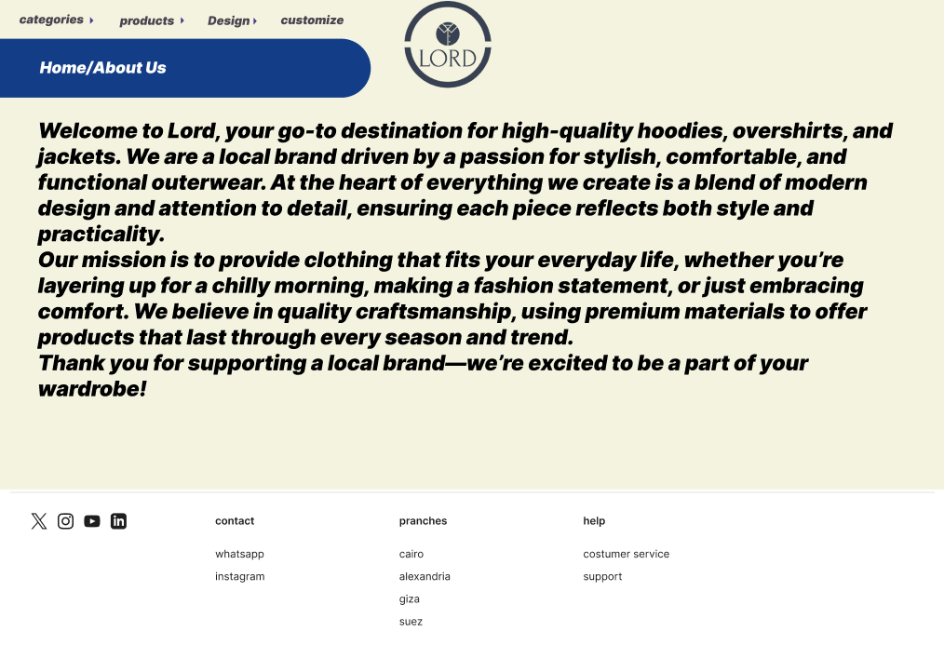

Login page

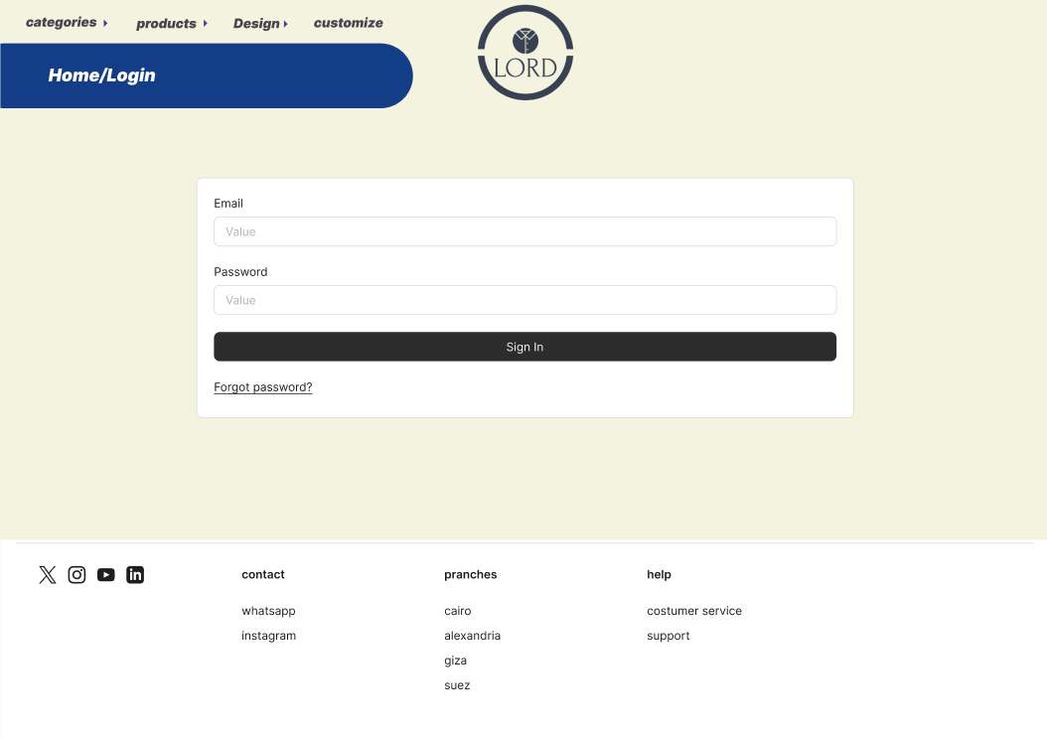

Customize page

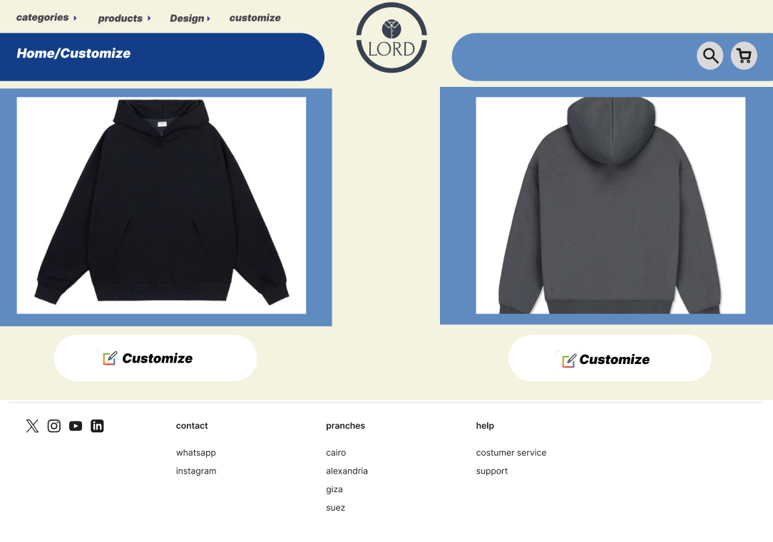

Color palette

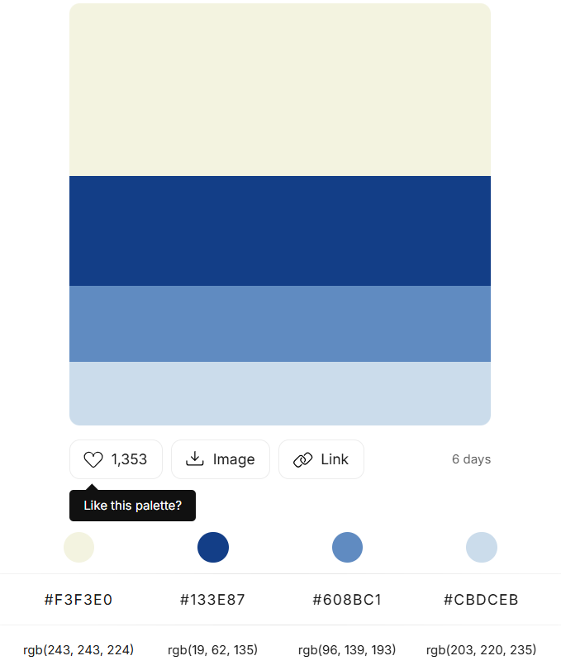

Home page/HTML5

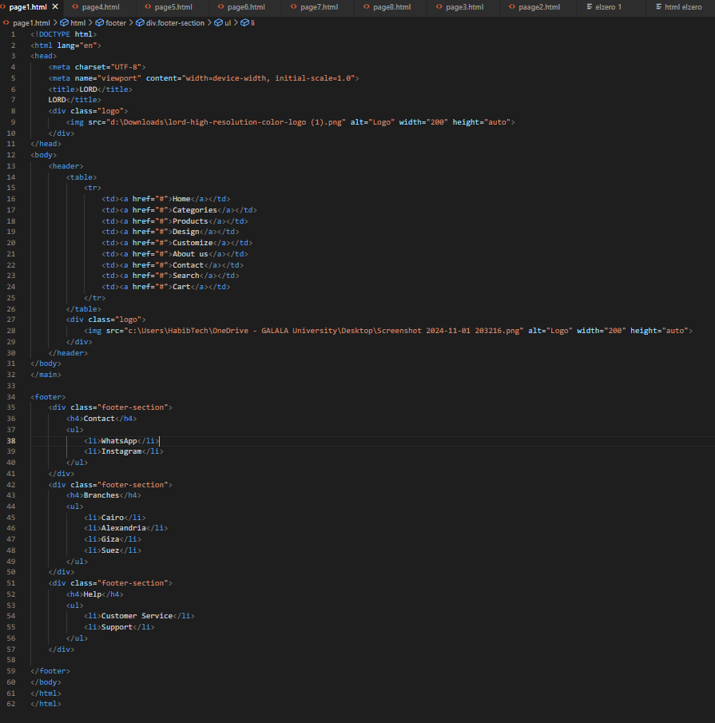

Categories page/HTML5

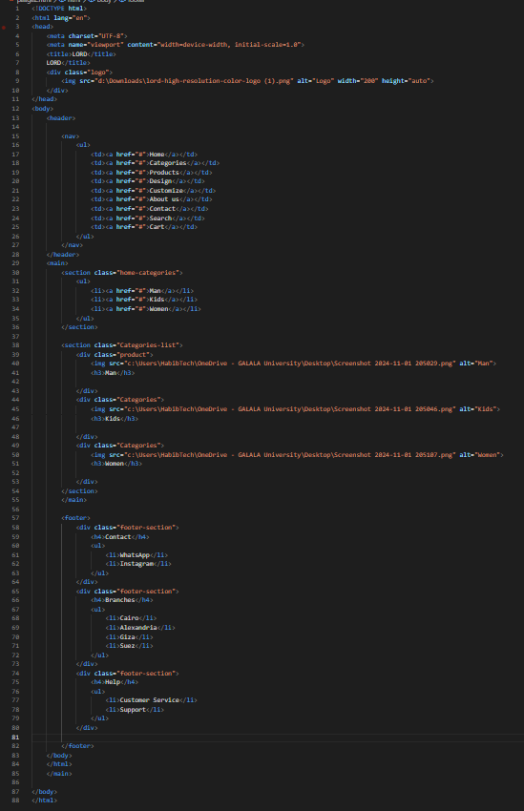

Products page/HTML5

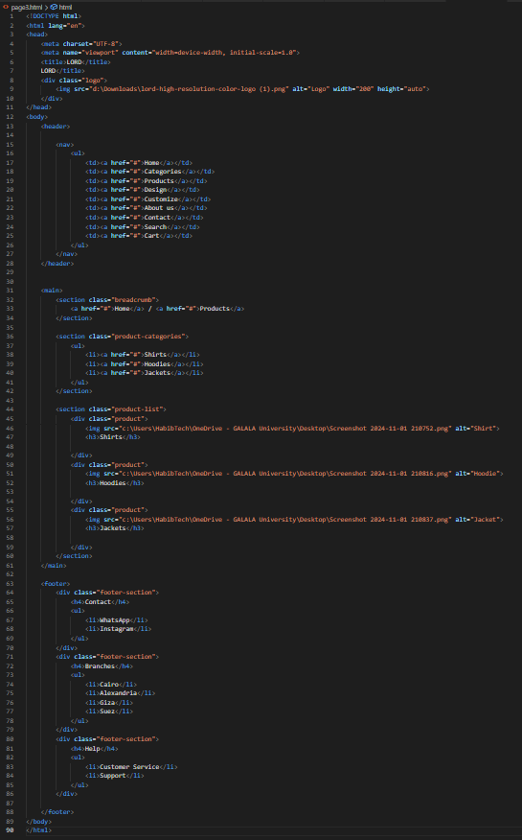

Design page/HTML5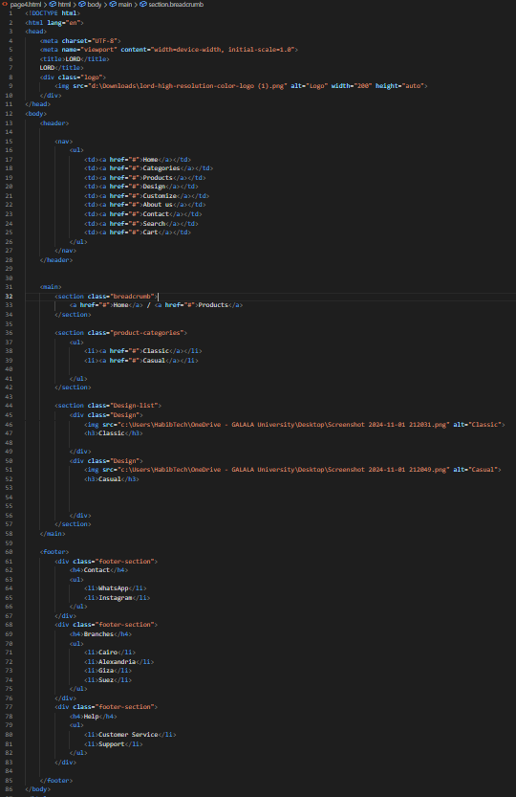

Contact-us page/HTML5

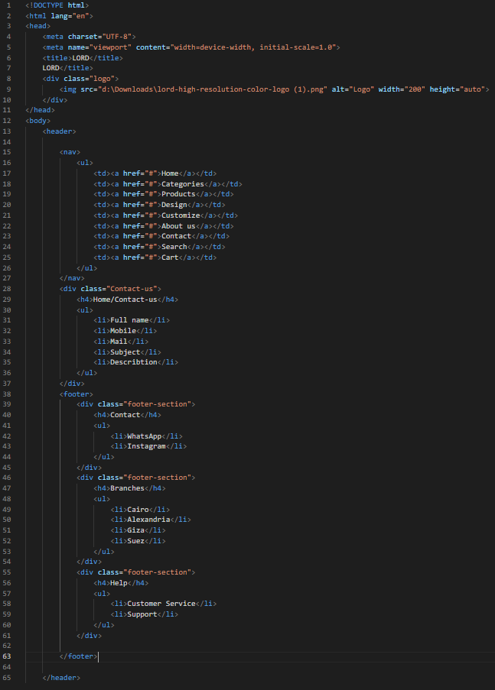

About-us page/HTML5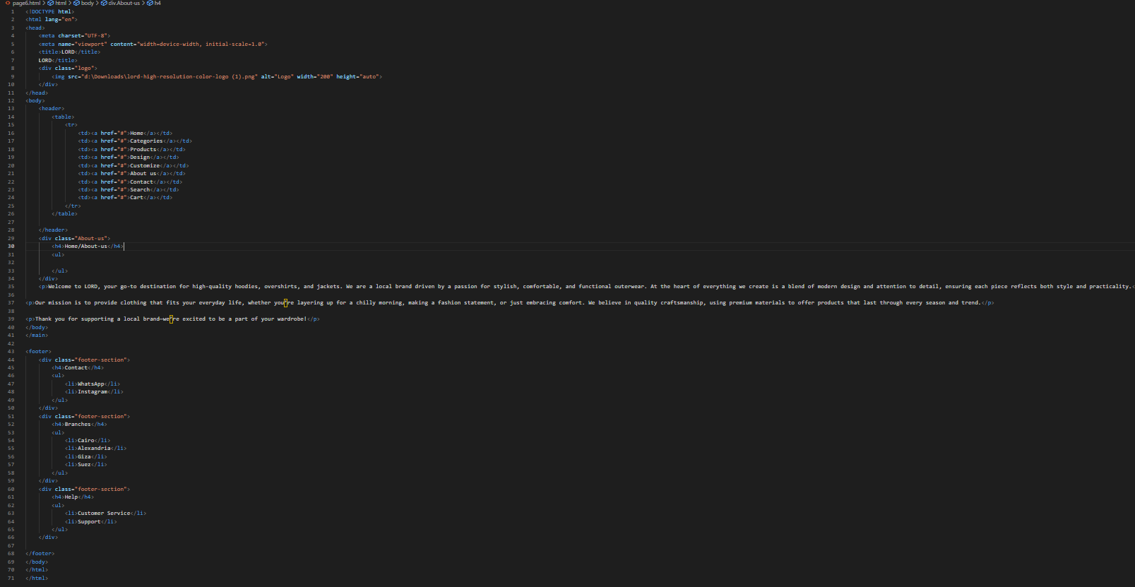

Login page/HTML5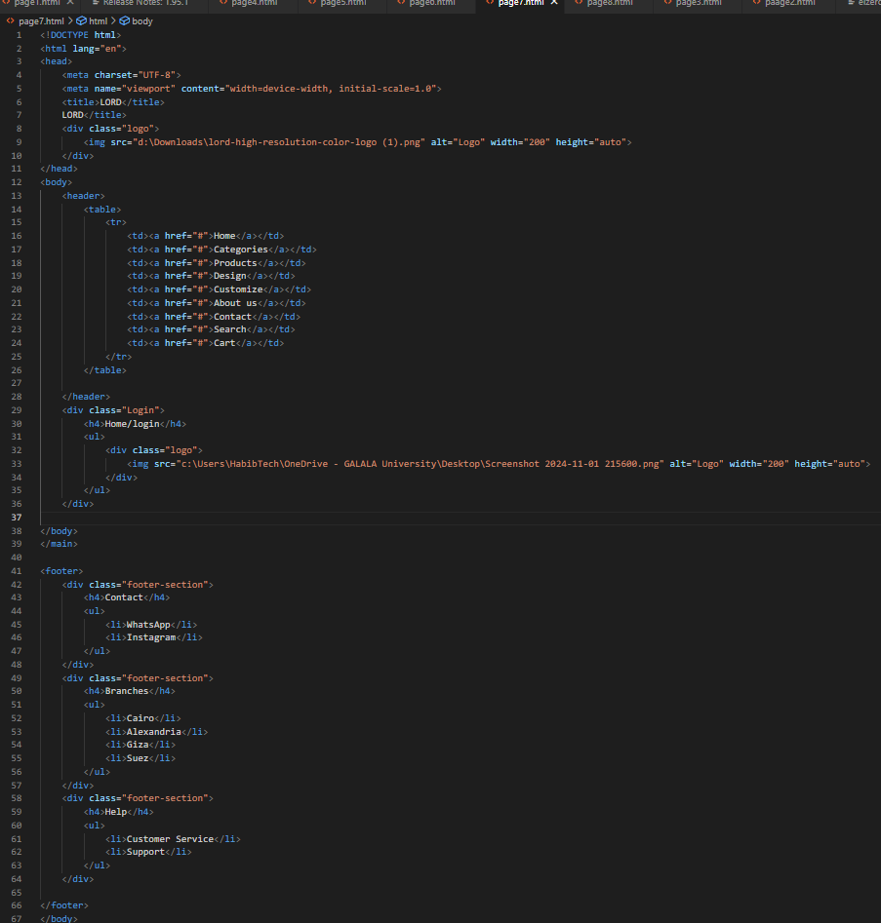

Customize page/HTML5

